Home & School Newsletter: Jan 2023

WHAT’S HAPPENING AT ST. PATS
2022 Recap  The fall season ended with a lot of Halloween fun at St Pats. The grade 6 students and teachers voted on the winning pumpkin and door decorations – one class from each grade won and celebrated with a pizza party on Dec 1st.  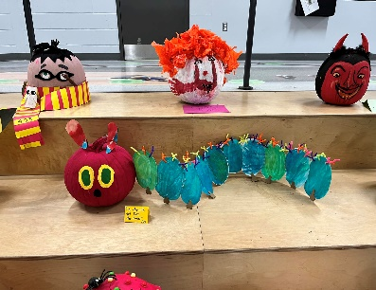  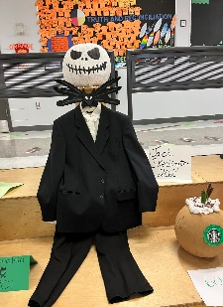  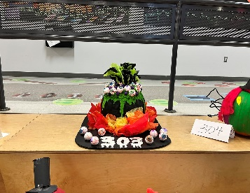  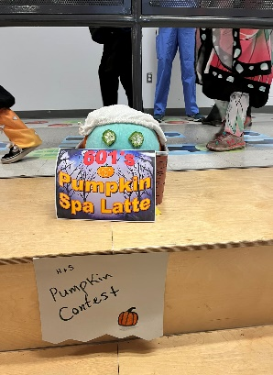  Congrats to the winning classes:  Saturday, Oct 29th – Halloqween Drive-In!      Home & School  vounteers were  also busy with the  return of Subway  lunches last year.  We know everyone is looking forward to the return of pizza lunches in the new year –dates later this month – so stay tuned! | Holiday Festivities Return!  When it came time to plan the holiday events at the school, many of us asked our children “what is your favorite part of the holidays at St Pats?” Almost unanimously they all said, “we miss eating together at the holiday lunch.” To make this a reality, parent elves spent weeks preparing by renting tables, locating decorations, and planning a kid-friendly menu that everyone could enjoy.  Parents, faculty, staff, and students were all able to enjoy this festive event that truly brought out the spirit of togetherness. Happy Holidays from the St Pats’ home and school!  Thanks to the city of Pincourt and the local businesses who donated and to ____ for putting all the donations together,  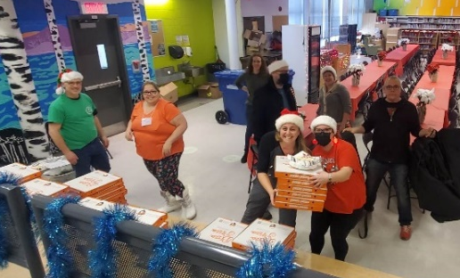  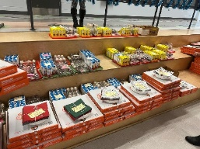  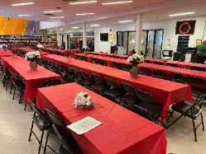 |  |  | PRESIDENT’S MESSAGE  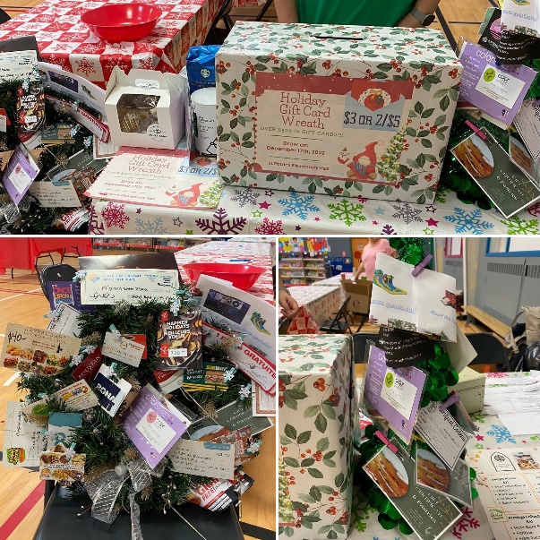  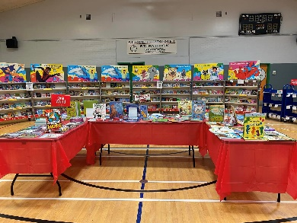
  Pumpkins:  - K05  - 101  - 202  - 303  - 404  - 501  - 601 | Doors:  - K01  - 103  - 201  - 302  - 403  - 561  - 603
WHERE DOES THE MONEY GO?
- Kindergarten
- Cycle 1
- Cycle 2
- Cycle 3
- Enrichment

Have you ever been curious what fundraiser money is used for? Here's a breakdown of the recent allocations. Read more on page 3.

As we prepare to celebrate the upcoming holidays with family and friends alike, let's first celebrate with our school community! Our little ones have taken on this school year with a courageous stride, so let's celebrate their spirit along with the season 💚 Home and School, with the help of school staff and admin, are elated to announce the return of our school Holiday Lunch! Parent elves will be serving up a delicious meal and even more of those elves will be working in the Santa Store. Classes will take turns visiting the store to pick out gifts for parents and our amazing St Pats Sixers will help with wrapping and labeling. What a day!
Closing out 2022, we say goodbye to a year filled with highs and lows, but with a fondness for the experience, let's usher in a renewed sense of friendship and belonging. From your Gnome and School, we wish you all the merriest and the brightest 2023. See you all next year

Mimi Tabaczuk
President
St. Patrick Elementary Home & School ©2023
Pot of Gold

SUMMARY OF RECENT EVENTS & FUNDRAISERS
Home & School Newsletter: Jan. 2023

Monthly Staff Coffee Breaks Return Pridewear Update
Each month, our faculty and staff are treated to a coffee break thanks to generous donations from parents.  It’s a small token of gratitude  for all they do for our kids every  day. Donate on our website: _________________________.  3rd prize (coffee & hot cocoa): Desiree Martinez  2nd prize (tree): Steven Cameron  1st prize (wreath): Christina Beyor  Thanks to everyone for supporting the St. Patrick H&S - and a special thanks to all the local businesses who donated! |  | Thanks to everyone who purchased school T-shirts, hoodies, and other school gear either at one of the curriculum nights, the Welcome Back BBQ or via our online store.  Shout out to our new Pridewear super star saleswoman, thank you Nadia Roswell for helping Home & School sell over $2,935 In Pridewear sales so far this year!  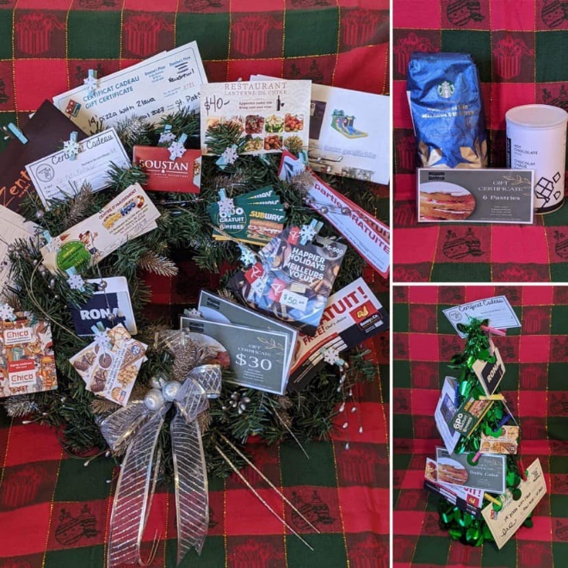  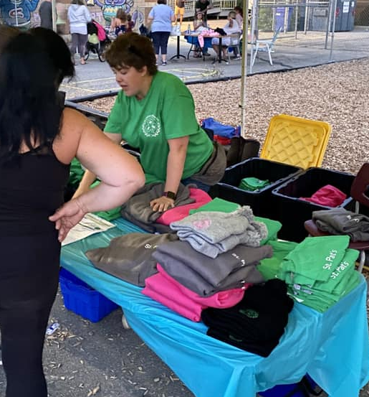


We’re always looking for volunteers to help with our in-school fundraisers and holiday events. Did you know that if you want to volunteer in the school or with a class on a field trip you need a police background check?

If you’re interested in volunteer opportunities for future events, please send an email to us at: stpatrickhomeandschool@lbpearson.ca.

Congrats to Annabell and Ms ___ for being seelcted to purchase extra items at the book fair,
Spotlight: Fundscrip
Looking for a creative way to send a gift to a friend, family member, or special teacher this holiday season? Look no further than Fundscrip – an easy way to send electronic gift cards, while giving back to our school. Check out the fundraising page of the H&S website (www.stpatshands.org) for more info.

Home & School Newsletter: Oct. 2022

ACTIVITIES AND ALLOCATIONS AT-A-GLANCE
Home & School Newsletter: Jan. 2023
Home & School Activities  NEW PLAYGROUND  _________________________.  REMINDER: M&M Vaudreuil Fundraiser  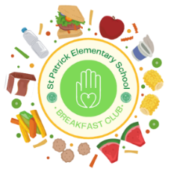    We are over the moon that M&M’s in Vaudreuil is still partnering with St. Pat’s – every time you shop there, don’t forget to mention our school and we get 10% back! How easy is that?  St. Pat’s Breakfast Club  The breakfast club pantry is thriving at St. Pats thanks to generous donations from our school community. The pantry is open to all students that need breakfast, whatever the reason. |  | Summary of Allocations:  $200.00 for Science Cupboard Supplies  - Allocation for additional funds to purchase consumables for all science teachers.  $1,337 for Sensory Station Supplies  - Allocation for the sensory stations in the Atrium for Ms. Nadia and Ms. Jessica.  $200.00 for Hot Chocolate for Choir  - Allocation for hot cocoa for the choir when they perform at John Abbott with the choir from Edgewater on Dec 18th./23rd?  $186.26 for Dry Erase Markers  - Allocation for a Mme Lynne to purchase dry erase markers for phonics games.  $193.81 for Word Play Kits  - Allocation for Mme Leblanc to purchase Word Play kits and other educational items.  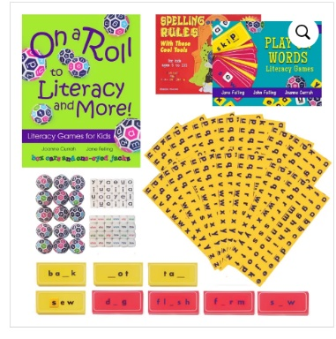  $500 for Santa Store  - Allocation to purchase additional
\

MARK YOUR CALENDARS!
2022/2023
Home & School Executives:
President:
Mimi Tabaczuk
Vice President:
Andrea Cappelli
Treasurer:
Melanie Bentley-Moore
Secretary:
Mary-Kate Jackson Yule
Membership:
Mary-Kate Jackson Yule
Volunteer Coordinator:
Tracy Rhodes
Communications Chair:
Gina Giambalvo

Check out some of the benefits of membership by clicking here.
Stay up to date on how you can support St Pats through Home & School:

Follow us on Facebook

Check out our website

Email us

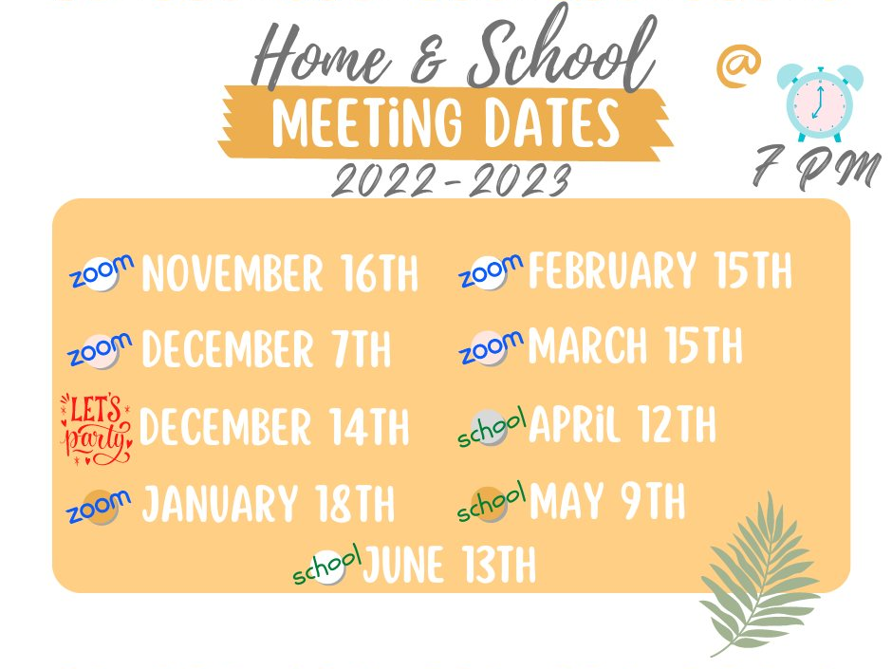

Have a question, or comment…contact H&S or GB for more info. Our meetings are open to all parents – join us anytime!

If you are interested in joining Governing Board (GB), email st_patrick_gb@lbpearson.ca to receive a zoom link or to have a question asked on your behalf. The next GB meeting is Thursday, January 26th at 6:30 PM.

GB

Contact us at stpatrickhomeandschool@lbpearson.ca or join us on Facebook: St. Patrick Home and School Association. Don’t forget to check our website periodically for all the latest Home & School news: www.spatshands.org. The next Home & School meeting is
Wednesday, January 18th at 07:00 PM on zoom. Send us an email if you’d like the zoom link to join the meeting.

H&S
Hope to see you then – everyone is welcome!




St. Patrick Elementary Home & School ©2023
Not yet a Member?  Join now! | Did you know: You can still be a member of Home & School, even if your kids are being homeschooled, or attending virtual school this year? Everyone is welcome – join on our website here: https://www.stpatshands.org/membership.

