Home & School Newsletter: Oct. 2022

WHAT’S HAPPENING AT ST. PATS
Welcome back to school!    The 2022/2023 school year began on August 30, and following the curriculum nights on September 1st and 8th, the St Pat’s Home & School Association was excited to bring back the fun of the Welcome Back BBQ/Carnival on Sept 9th! After a 2-year break it was great to see everyone back in person, enjoying food and fun in our schoolyard.  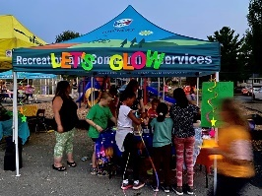  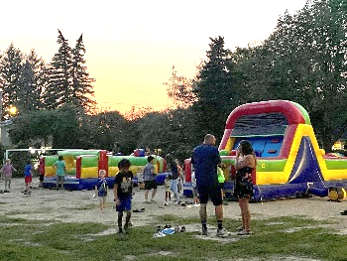  Thank you to our teacher volunteers who signed up to get “splashed for cash”. Each teacher who sat in the wet seat received $100 for their classroom. Thanks to Ms. Gibson, Mme. Murphy, Mr. Patterson, Ms. Leblanc, and Mr. Pigas for being great sports!  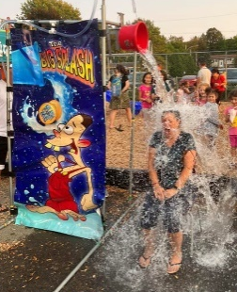  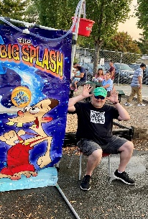 | This event would not have been possible without our amazing parent and community volunteers – Thank you to everyone who helped make this event a success!  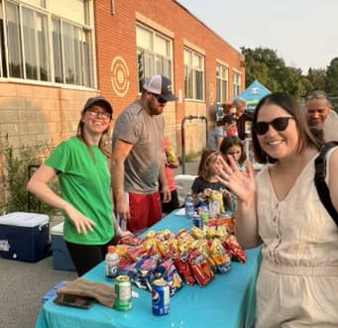  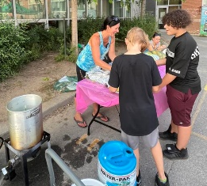  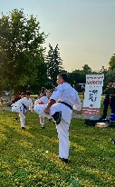  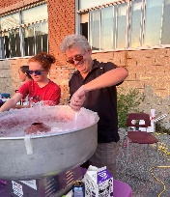  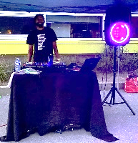  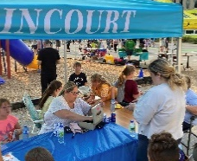  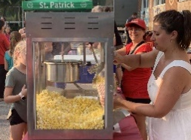  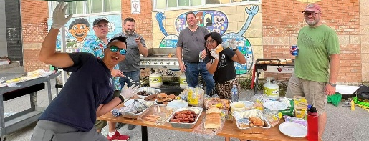  We’re looking forward to many more fun events for the school as the year goes on. Stay tuned for more information about our fall movie nights, holiday themed contests, fun lunches, and more!  If you’re interested in volunteer opportunities for future events, visit our website stpatshands.org. |  |  | PRESIDENT’S MESSAGE
WHERE DOES THE MONEY GO?
- Kindergarten
- Cycle 1
- Cycle 2
- Cycle 3
- Enrichment

Have you ever been curious what fundraiser money is used for? Here's a breakdown of the recent allocations. Read more on page 3.

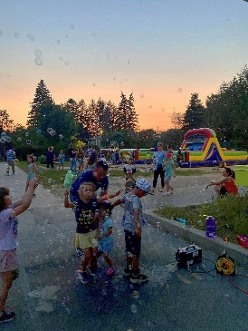
Can it really be October already?! Just yesterday we were all eating freezies at the H&S carnival! It was so uplifting to see all our families having fun at the school again!

As in years past, H&S began the school year to a fevered pitch. Following the carnival, we had our annual Pridewear sale and our first monthly staff coffee break and delivering $350 worth of sand to the playground sandbox.

October is full of even more fun with the return of our annual pumpkin and classroom door decorating contests. The winners will receive a pizza party in class!

This month will also see the return of Subway lunches, with TCBY treats to boot. We are SO excited to bring back ice cream! We've been without TCBY for 2 human years, but in ice cream years that's more like 20!

Lastly, but certainly not leastly, we are so spookily excited to announce a Halloween-themed Drive-In Movie Weekend at Quinn Farm on October 28th and 29th. Arrive in costume for a free glow bracelet! We'll be in costume too ;) Purchase tickets by following the link on our Facebook page, website (stpatshands.org) or through an email shared by the school.

I'm really looking forward to another great year with all of you, my last year at St Pats. 3 kids and 14 years later what a ride! 🍀💚🍀

Mimi Tabaczuk
President

St. Patrick Elementary Home & School ©2022
Pot of Gold

SUMMARY OF RECENT EVENTS & FUNDRAISERS
Home & School Newsletter: Oct. 2022

Monthly Staff Coffee Breaks Pridewear Update
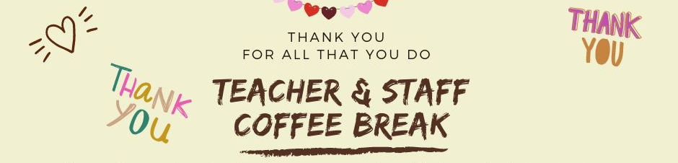    Each month, our faculty and  staff are treated to a coffee  break thanks to generous  donations from parents.  It’s a small token of gratitude  for all they do for our kids every  day. Don’t forget to use password  “shamrock” for eTransfers and  include any notes of appreciation  (including names and classroom  info) along with your donation  to Home & School at stpatrickhomeandschool@lbpearson.ca. |  | Thanks to everyone who purchased school T-shirts, hoodies, and other school gear either at one of the curriculum nights, the Welcome Back BBQ or via our online store.  Shout out to our new Pridewear super star saleswoman, thank you Nadia Roswell for helping Home & School sell over $2,935 In Pridewear sales so far this year!  Congratulations to Joumana Choucair for winning our free hoodie draw. Enjoy your hot pink hoodie!  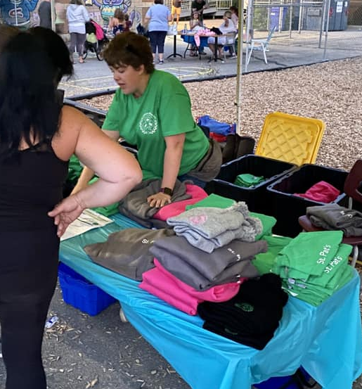  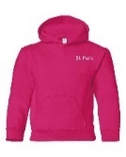

Update from Governing Board
Dear St. Patrick's Community,
St Pat’s Pridewear is on its way!
If you have purchased an item that is not in stock, it will be delivered to your child’s classroom as soon as it comes in. You will receive an update from Home & School once we have all the items. Visit our website anytime to place an order: https://www.stpatshands.org/pridewear.

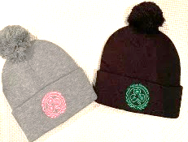
Did you know that the Governing Board of St. Pats meets monthly and is open to all parents?

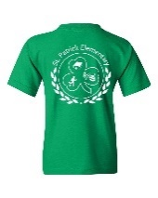
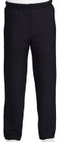
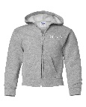

The Governing Board acts as a consulting group for budgets, educational projects, field trips and fundraisers. Any parent can join a meeting to be more informed on current or upcoming events. You can also raise questions during the public question period. group for the school and is responsible for adopting/approving

If you are interested in joining us, please email me at st_patrick_gb@lbpearson.ca to receive a zoom link or send me a question to ask on your behalf.
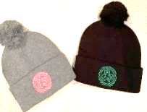

Warmest Wishes,
Doug Bentley
GB Chair 2022/23
Spotlight: Fundscrip
Looking for a creative way to send a gift to a friend, family member, or special teacher this holiday season? Look no further than Fundscrip – an easy way to send electronic gift cards, while giving back to our school. Check out the fundraising page of the H&S website (www.stpatshands.org) for more info.

Home & School Newsletter: Oct. 2022

ACTIVITIES AND ALLOCATIONS AT-A-GLANCE
Home & School Newsletter: Oct. 2022
Home & School Activities    School Playground Update  All hands on deck! The Home & School is looking for several volunteers to help touch up the paint on the playground. All are welcome – the more help, the faster it will go (no prior artistic experience required).  PIZZA & SUBWAY Lunches to Begin in October    Pizza and Subway lunches are back again this year! Each month, students (and parents) can enjoy a treat on Fridays with lunch provided by Subway from now until winter break. Pizza lunches will return in the new year. Orders can be placed via our H&S website this year.  Police Checks Mandatory for All Volunteers  Many parents want to take an active role and volunteer in school, either for field trips, in classrooms, or at Home & School events. To volunteer for any event in the school, sponsored by Home & School or organized by the school itself, a police check is mandatory. These checks are valid for 3 years – contact the main office or H&S for more information if you need to complete a police check.  REMINDER: M&M Vaudreuil Fundraiser  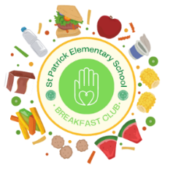    We are over the moon that M&M’s in Vaudreuil is still partnering with St. Pat’s – every time you shop there, don’t forget to mention our school and we get 10% back! How easy is that?  St. Pat’s Breakfast Club  The breakfast club pantry is thriving at St. Pats thanks to generous donations from our school community. The pantry is open to all students that need breakfast, whatever the reason. |  | Summary of Allocations:  $138.03 for Brain Bins  - Allocation for a series of educational tools for K01/K02.  $179.28 for Brain Bin/Fine Motor Skills Items  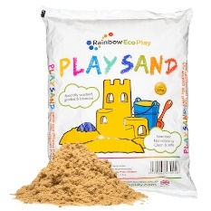  - Allocation for magnetic blocks, sensory pipe tubes, building blocks, sand timer, straw connectors and other STEM items for K03/K04.  $350 for Sand for the Playground  - Allocation for sand to refill the sandbox on the St Pat’s playground.    $230 for Zoom Account  - Allocation for a zoom account for the Home & School meetings for the 2022/23 school year.  $200 for 550 Juice Boxes for the Terry Fox Run    - Allocation to purchase juice boxes for all students participating in the Terry Fox Run on Sept 28th.    $200 for Music Play Online  - Allocation to renew the subscription for Music Play Online account for Mr. Blake/Jr. Music.    $800 for Halloween Contests  - Allocation to purchase pumpkins for pumpkin decorating contest and pizza for prize lunches for pumpkin and door decorating contests.    $1,300 for QPAT Teacher’s Convention  - Allocation to cover the cost of classroom enrichment items purchased at the QPAT annual Teachers Conference for the faculty at St. Pats.  $500 for Breakfast Club Pantry Items  - Allocation to purchase additional non-perishable items for the St. Pat’s Breakfast Club pantry.
\

UPCOMING EVENTS & FUNDRAISERS
2022/2023
Home & School Executives:
President:
Mimi Tabaczuk
Vice President:
Andrea Cappelli
Treasurer:
Melanie Bentley-Moore
Secretary:
Mary-Kate Jackson Yule
Membership:
Mary-Kate Jackson Yule
Volunteer Coordinator:
Tracy Rhodes
Communications Chair:
Gina Giambalvo

Check out some of the benefits of membership by clicking here.
Stay up to date on how you can support St Pats through Home & School:

Follow us on Facebook

Check out our website

Email us

 | SUN | MON | TUES | WED | THURS | FRI | SAT
OCTOBER | 2 | 3  NO SCHOOL | 4 | 5 | 6 | 7 | 8
OCTOBER | 9 | 10  NO SCHOOL | 11 | 12 | 13 | 14  NO SCHOOL | 15
OCTOBER | 16 | 17 | 18 | 19  H&S Meeting | 20 | 21 | 22
OCTOBER | 23 | 24 | 25 | 26  GB Meeting | 27 |   28  Movie Night | 29  Movie Night
OCTOBER | 30 | 31

Have a question, or comment…contact H&S or GB for more info. Our meetings are open to all parents – join us anytime!

If you are interested in joining Governing Board (GB), email st_patrick_gb@lbpearson.ca to receive a zoom link or to have a question asked on your behalf. The next GB meeting is Wednesday, October 26th at 6:30 PM.

GB

Contact us at stpatrickhomeandschool@lbpearson.ca or join us on Facebook: St. Patrick Home and School Association. Don’t forget to check our website periodically for all the latest Home & School news: www.spatshands.org. The next Home & School meeting is
Wednesday, October 19th at 07:00 PM. it will be held in person in the conference room in the school for our getting to know each other meeting. Everyone will bring a treat to share! From November to March our meeting will continue on Zoom.

H&S
Hope to see you then – everyone is welcome!




St. Patrick Elementary Home & School ©2022
Not yet a Member?  Join now! | Did you know: You can still be a member of Home & School, even if your kids are being homeschooled, or attending virtual school this year? Everyone is welcome – join on our website here: https://www.stpatshands.org/membership.

