Home & School Newsletter: Dec. 2022

WHAT’S HAPPENING AT ST. PATS

What a busy time of year!  Last month ended with a lot of Halloween fun – the grade 6 students and teachers voted on the winning pumpkin and door decorations – one class from each grade that wins celebrated with a pizza party on Dec 1st.  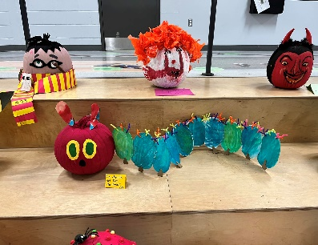  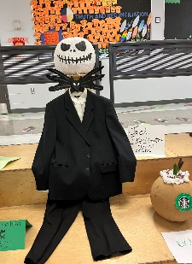  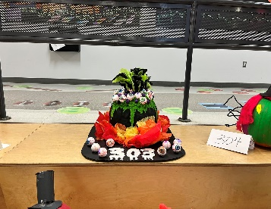  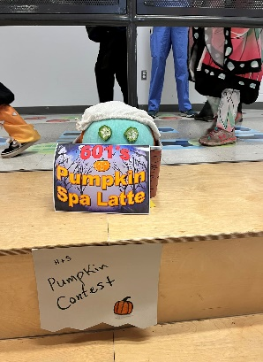  Congrats to the winning classes:      Home & School  vounteers were  also busy with the  return of Subway  lunches. One  more to go before  the holiday break.  We know everyone is looking forward to the return of pizza lunches in the new year too! Can’t wait to bring these back in January. | We’re always looking for volunteers to help with our in-school fundraisers and holiday events. Did you know that if you want to volunteer in the school or with a class on a field trip you need a police background check?  If you’re interested in volunteer opportunities for future events, please send an email to us at: stpatrickhomeandschool@lbpearson.ca.  As we get ready for the holiday season, the Home & School elves are busy with preparations for the return of the Santa Store and holiday lunch!    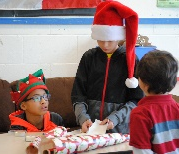  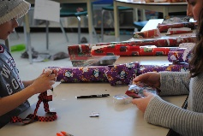  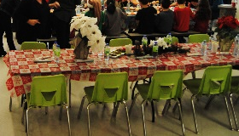  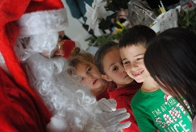  This year there will be even more fun with our virtual holiday market and book fair – join us on Dec 16th and/or 17th for some last-minute shopping and to pick up your online orders.  Check out page 2 for more information about the holiday happenings at St Pats! |  |  | PRESIDENT’S MESSAGE
  Pumpkins:  - K05  - 101  - 202  - 303  - 404  - 501  - 601 | Doors:  - K01  - 103  - 201  - 302  - 403  - 561  - 603
WHERE DOES THE MONEY GO?
- Kindergarten
- Cycle 1
- Cycle 2
- Cycle 3
- Enrichment

Have you ever been curious what fundraiser money is used for? Here's a breakdown of the recent allocations. Read more on page 3.
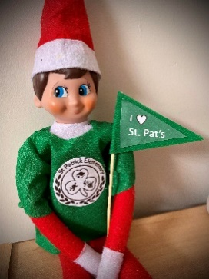

Placeholder

Mimi Tabaczuk
President

St. Patrick Elementary Home & School ©2022
Pot of Gold

SUMMARY OF RECENT EVENTS & FUNDRAISERS
Home & School Newsletter: Dec. 2022

Monthly Staff Coffee Breaks Return Pridewear Update
Thanks to everyone who purchased school T-shirts, hoodies, and other school gear either at one of the curriculum nights, the Welcome Back BBQ or via our online store.
Shout out to our new Pridewear super star saleswoman, thank you Nadia Roswell for helping Home & School sell over $2,935 In Pridewear sales so far this year!
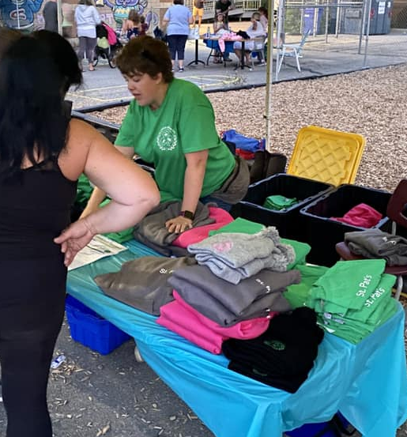
Spotlight: Fundscrip
Looking for a creative way to send a gift to a friend, family member, or special teacher this holiday season? Look no further than Fundscrip – an easy way to send electronic gift cards, while giving back to our school. Check out the fundraising page of the H&S website (www.stpatshands.org) for more info.

Home & School Newsletter: Oct. 2022

ACTIVITIES AND ALLOCATIONS AT-A-GLANCE
Home & School Newsletter: Dec. 2022
Home & School Activities    Monthly Staff Coffee Breaks Return  Each month, our faculty and staff are  treated to a coffee break thanks to  generous donations from parents.  It’s a small token of gratitude  for all they do for our kids every  day. Donate on our website: _________________________.  REMINDER: M&M Vaudreuil Fundraiser  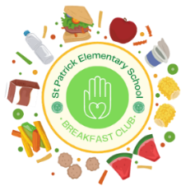    We are over the moon that M&M’s in Vaudreuil is still partnering with St. Pat’s – every time you shop there, don’t forget to mention our school and we get 10% back! How easy is that?  St. Pat’s Breakfast Club  The breakfast club pantry is thriving at St. Pats thanks to generous donations from our school community. The pantry is open to all students that need breakfast, whatever the reason. |  | Summary of Allocations:  $138.03 for Brain Bins  - Allocation for a series of educational tools for K01/K02.  $179.28 for Brain Bin/Fine Motor Skills Items  - Allocation for magnetic blocks, sensory pipe tubes, building blocks, sand timer, straw connectors and other STEM items for K03/K04.  $350 for Sand for the Playground  - Allocation for sand to refill the sandbox on the St Pat’s playground.  $230 for Zoom Account  - Allocation for a zoom account for the Home & School meetings for the 2022/23 school year.  $200 for 550 Juice Boxes for the Terry Fox Run  - Allocation to purchase juice boxes for all students participating in the Terry Fox Run on Sept 28th.  $200 for Music Play Online  - Allocation to renew the subscription for Music Play Online account for Mr. Blake/Jr. Music.  $800 for Halloween Contests  - Allocation to purchase pumpkins for pumpkin decorating contest and pizza for prize lunches for pumpkin and door decorating contests.  $1,300 for QPAT Teacher’s Convention  - Allocation to cover the cost of classroom enrichment items purchased at the QPAT annual Teachers Conference for the faculty at St. Pats.  $500 for Breakfast Club Pantry Items  - Allocation to purchase additional non-perishable items for the St. Pat’s Breakfast Club pantry.
\

UPCOMING EVENTS & FUNDRAISERS
2022/2023
Home & School Executives:
President:
Mimi Tabaczuk
Vice President:
Andrea Cappelli
Treasurer:
Melanie Bentley-Moore
Secretary:
Mary-Kate Jackson Yule
Membership:
Mary-Kate Jackson Yule
Volunteer Coordinator:
Tracy Rhodes
Communications Chair:
Gina Giambalvo

Check out some of the benefits of membership by clicking here.
Stay up to date on how you can support St Pats through Home & School:

Follow us on Facebook

Check out our website

Email us

 | SUN | MON | TUES | WED | THURS | FRI | SAT
DECEMBER |  |  |  |  | 1 | 2 | 3
DECEMBER | 4 | 5 | 6 | 7  H&S Meeting | 8 | 9   | 10
DECEMBER | 11 | 12 | 13 | 14 | 15  GB Meeting | 16  Holiday Lunch | 17
DECEMBER | 18 | 19 | 20 | 21 | 22 | 23  Staff Coffee | 24
DECEMBER | 25 | 26 | 27 | 28 | 29 | 30 | 31

Have a question, or comment…contact H&S or GB for more info. Our meetings are open to all parents – join us anytime!

If you are interested in joining Governing Board (GB), email st_patrick_gb@lbpearson.ca to receive a zoom link or to have a question asked on your behalf. The next GB meeting is Thursday, December 15th at 6:30 PM.

GB

Contact us at stpatrickhomeandschool@lbpearson.ca or join us on Facebook: St. Patrick Home and School Association. Don’t forget to check our website periodically for all the latest Home & School news: www.spatshands.org. The next Home & School meeting is
Wednesday, December 7th at 07:00 PM on zoom. Send us an email if you’d like the zoom link to join the meeting.

H&S
Hope to see you then – everyone is welcome!




St. Patrick Elementary Home & School ©2022
Not yet a Member?  Join now! | Did you know: You can still be a member of Home & School, even if your kids are being homeschooled, or attending virtual school this year? Everyone is welcome – join on our website here: https://www.stpatshands.org/membership.

